CHAPTER 2
METHODOLOGY
  - BLOCK DIAGRAM

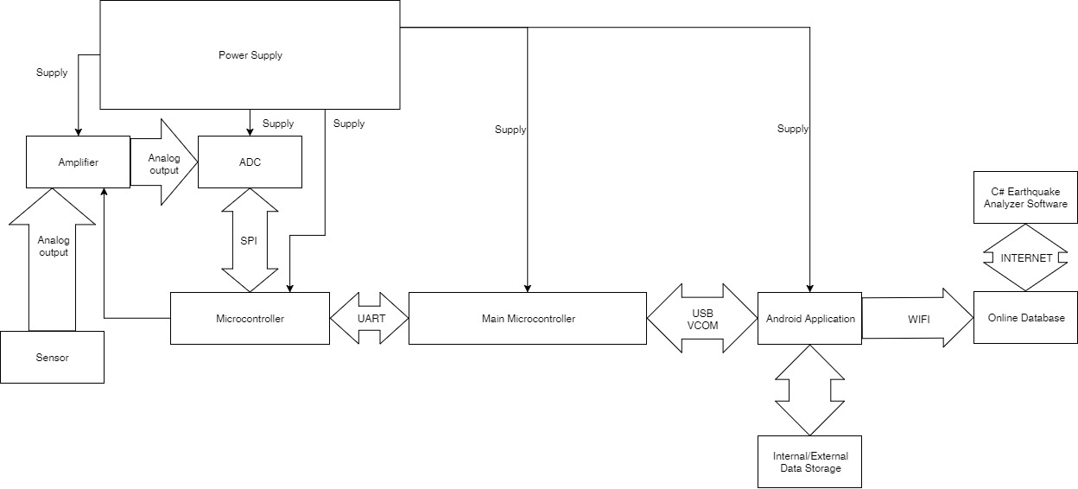

Figure 2.1 Block Diagram

The block diagram of the system is shown by figure 2.1. The signals generated by the sensor were amplified and received by the ADC. The signals were then converted into 24 bit digital resolution and passed to the microcontroller. The converted data were appended by the microcontroller and were passed to the Android phone via USB VCOM. The converted data were displayed and appended with time, compass, and location information by the Android phone. The completed data were then back-up in the external/internal storage and be send to the online database.

  - PROJECT MANAGEMENT

    - Materials and Resources

Converting a single axis into 24 bits resolution includes three components namely: ADC, Microcontroller for buffer, and, amplifier. These components have each respected function. Amplifier is used for amplifying small signals generated by the sensor. The microcontroller act as buffer for the converted data from the ADC. This microcontroller is also responsible for transferring data to the primary microcontroller.

Material/Resource | Quantity | Cost
ADC | 3 | 400
Microcontroller for data conversion and buffer | 3 | 250
Primary microcontroller for data transfer | 1 | 300
Amplifier | 3 | 250
Android phone | 1 | 5000
Local Database | 1 | 15K
Power Supply | 1 | 1500
Total Cost |  | 22,700

Table 2.2.1.1 Materials and Resources

    - Gantt Chart
TASK | MONTH | JULY |  |  |  | AUGUST |  |  |  | SEPT |  |  |  | OCT
TASK | WEEK | 1 | 2 | 3 | 4 | 1 | 2 | 3 | 4 | 1 | 2 | 3 | 4 | 1 | 2 | 3 | 4
Research Study
Project Proposal
Feasibility of Project
SRS: Chapter 1 Introduction
  - Purpose
  - Scope
  - Project Constraints and Limitation
  - Hardware
  - Software Requirements
  - Definition of Terms
References
Chapter 2 System Analysis
2.1 System Architecture
  - 2.2 Flowcharts
Chapter 3 Functional Requirement
Chapter 4 User Interface
Chapter 1 Introduction
  - Problem Background
  - Project Goals & Objectives
Significance of the Study
  - Theoretical Background
  - Review of Related Literature
  - Definition of Terms
Chapter 2 Methodology
2.1 Block Diagram
2.2 Project Management
  - 2.3 Prototype Design
  - Circuit Design
  - Program Flowchart
Test and Data Gathering
  - Compilation of Documents
Presentation/Defense

Table 2.2.2.1 Gantt Chart Research and Design phase

TASK | MONTH | NOV |  |  |  | DEC |  |  |  | JAN |  |  |  | FEB |  |  |  | MAR
TASK | WEEK | 1 | 2 | 3 | 4 | 1 | 2 | 3 | 4 | 1 | 2 | 3 | 4 | 1 | 2 | 3 | 4 | 1 | 2 | 3 | 4
Gathering of
Materials
Developing of circuit
Programming
Testing
Prototyping

Table 2.2.2.2 Gantt Chart Implementation phase

  - PROTOTYPE DESIGN

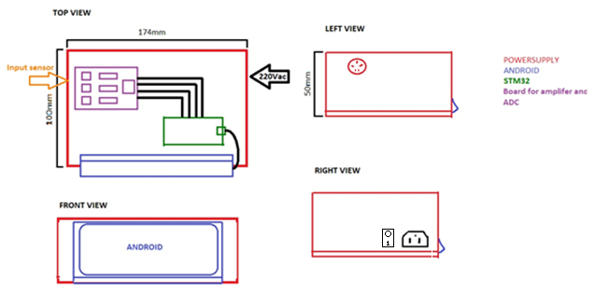

Figure 2.3.1 Prototype Design

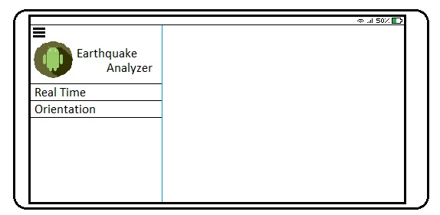

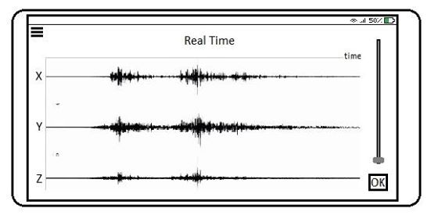

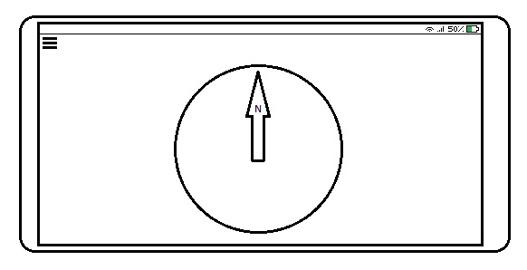

Figure 2.3.2 User Interface

In Figure 2.3.1, the prototype of the design is shown. The top view of the design shows the board where it houses the circuit of the system. The green component represents the main microcontroller. The blue component represents the android phone. In the left side view, the input port of the accelerometer is shown. While in the right-side view, the power port and the power switch is shown. In Figure 2.3.2, the GUI is also shown above. The first screen is the drop down screen where the Real Time view and The Orientation View buttons can be accessed. Then the Real Time Screen is show bellow the drop down screen. In the Real Time Screen, the X, Y, and Z-axis is shown. Next to the Real Time Screen is the Orientation Screen. Inside the Orientation Screen is the Compass.
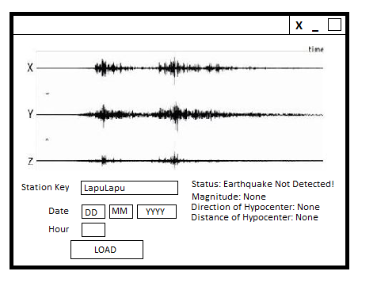
Figure 4.2.4 Earthquake Analyzer Interface

Figure 4.2.4 shows the user interface for the Earthquake Analyzer software. The user will be asked to input a station key, date, and hour of the file that the user wanted. When the user click “Load”, the software will request the file though API.

  - CIRCUIT DESIGN

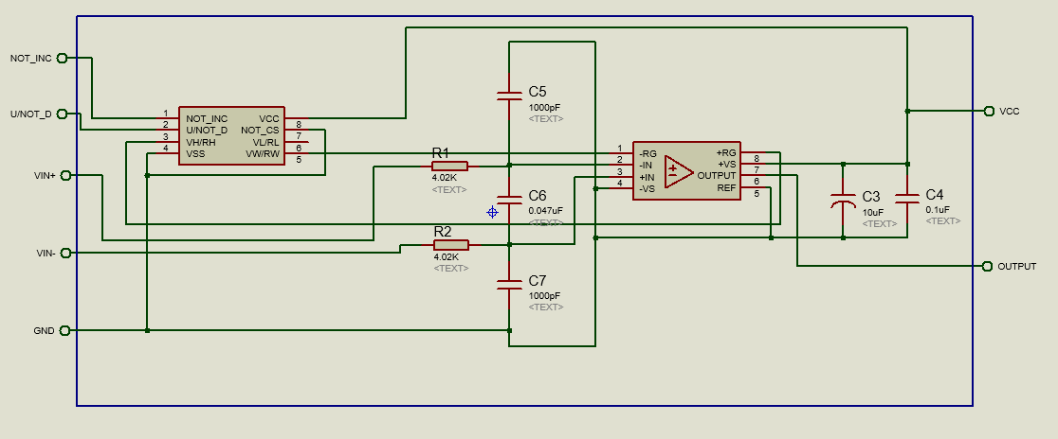

Figure 2.4.1 Amplifier Circuit Design

The amplifier design is shown in the circuit above. There are two major components shown here, namely, the digital potentiometer and instrumentation amplifier. The digital potentiometer act as a gain controller for the in-amp. The potentiometer controls specifically the variable resistor (Rg) part of the in-amp. The in-amp amplifies signal coming from the sensor. The gain can have as high as 1000 and as low as 1. The input signals of the in-amp is being filtered by the parallel capacitors to prevent RF interference. The in-amp has also decoupling capacitors for the supply.

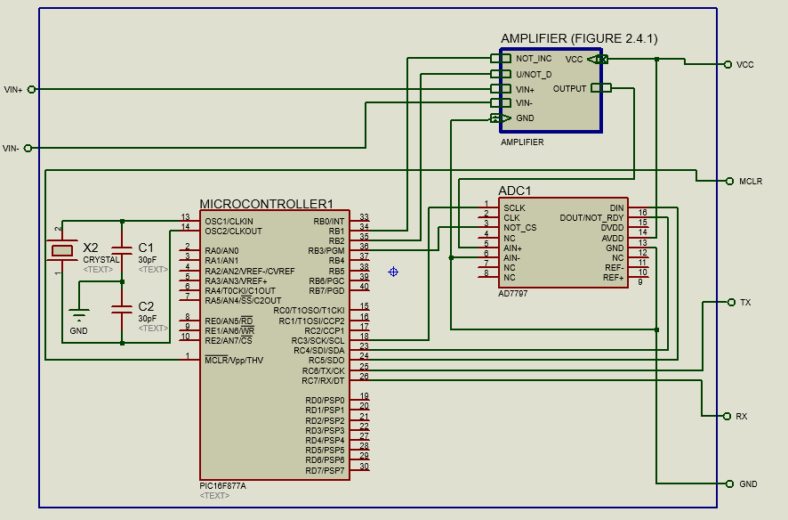

Figure 2.4.2 ADC Circuit Design

The ADC circuit design is shown on figure 2.4.2. The microcontroller act as a buffer and at the same time controller for the gain of amplifier. The output of the amplifier is being fed to the ADC. The ADC then converts the incoming signals from the amplifier into 24 bit digital resolution. The output of the ADC is being fed to the microcontroller through SPI interface. The microcontroller then send the data to the main microcontroller through UART.

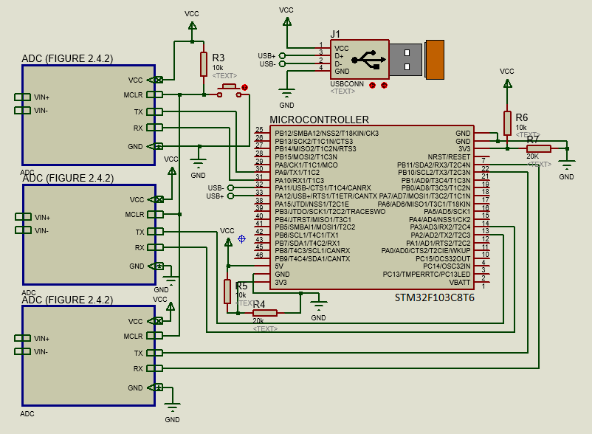

Figure 2.4.3 Main Controller Design

The main controller circuit is shown in this figure 2.4.3. The microcontroller shown in this figure is the main microcontroller of the system. Data from all ADC are received by this microcontroller. The data will be appended with time bits from the RTC. The main microcontroller will frequently check its time if it synchronize with the UTC using Android. The communication between android and main microcontroller is through USB.

  - PROGRAM FLOWCHART
    - General Flowchart
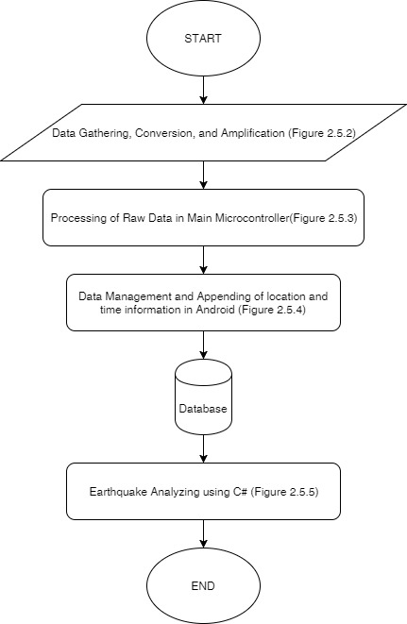
Figure 2.5.1 General Flowchart
Figure 2.5.1 shows the general flowchart of the system. This describes the overall flow of the system from data gathering until C# back end software of the system.

    - Data Gathering, Conversion, and Amplification
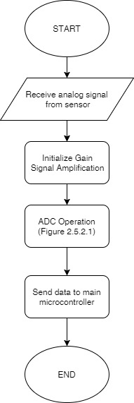
Figure 2.5.2 Data Gathering, Conversion, and Amplification
This figure shows the general flowchart of data gathering, conversion, and amplification. Sub flowcharts, figure 2.5.2.1 and 2.5.2.2, will be shown below.

      - ADC Operation
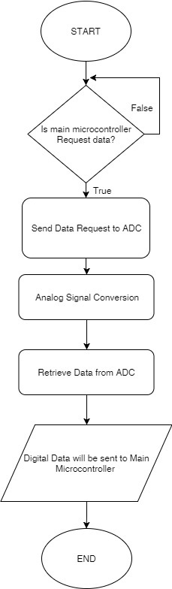
Figure 2.5.2.1 ADC Operation
The ADC module is controlled by a sub microcontroller which is responsible for data acquisition request. The figure above shows the flowchart of data acquisition of the sub microcontroller.
    - Processing of Raw Data in Main Microcontroller
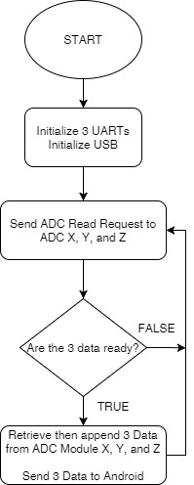
Figure 2.5.3 Processing of Raw Data in Main Microcontroller
The figure above shows the flowchart of the main microcontroller. The microcontroller is responsible for combining X, Y, and Z values into one data which will be passed to Android Phone.
    - Data Management and Appending of location and time information in Android
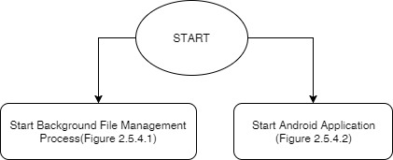
Figure 2.5.4 Android Software General Operation
The figure above shows the general operation of the android software. The Android software is responsible for appending time and location information to the received raw data, creating back-up, sending data to an online database, and displaying the data in a graphical form using Android phone. The two process shown above are run simultaneously since the Android phone is capable of multitasking. The Background File Management Process is running in background process while the Android Application will run on user’s choice.

      - Background File Management Service
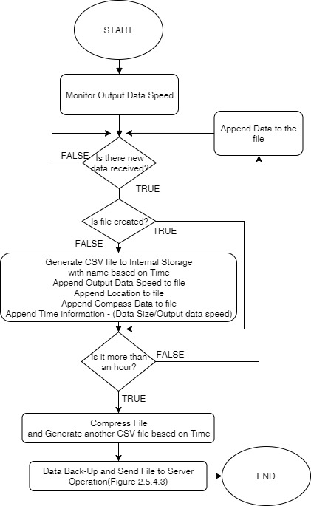
Figure 2.5.4.1 Background File Management Service
The figure above describes the background file management service flowchart for Android. This will run in background process and its responsibility is to receive data from the digitizer system and append location and time information to the file.
      - Android Application
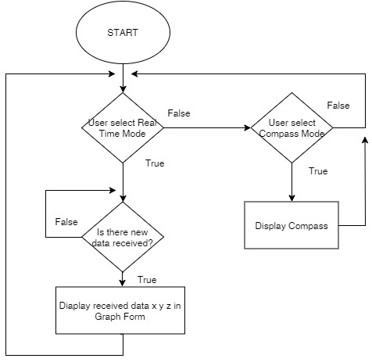
Figure 2.5.4.2 Android Application
The figure above shows the android application flowchart. The user can select two modes: Compass and Real Time mode. In real time mode, the system will display the data. In compass mode, the system will display virtual compass.

      - Data Back-Up and Send file to the Cloud
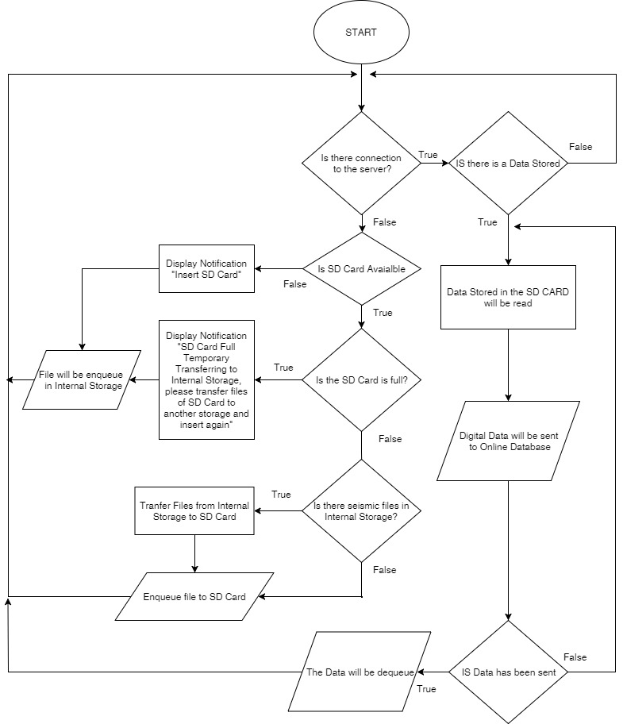
Figure 2.5.4.3 Data Back-up and Send File to Cloud
The figure above shows the sub function of the Background File Management Service of the Android software. Its main function is to generate back-up and send file to the database.
    - Earthquake Analyzing using C#
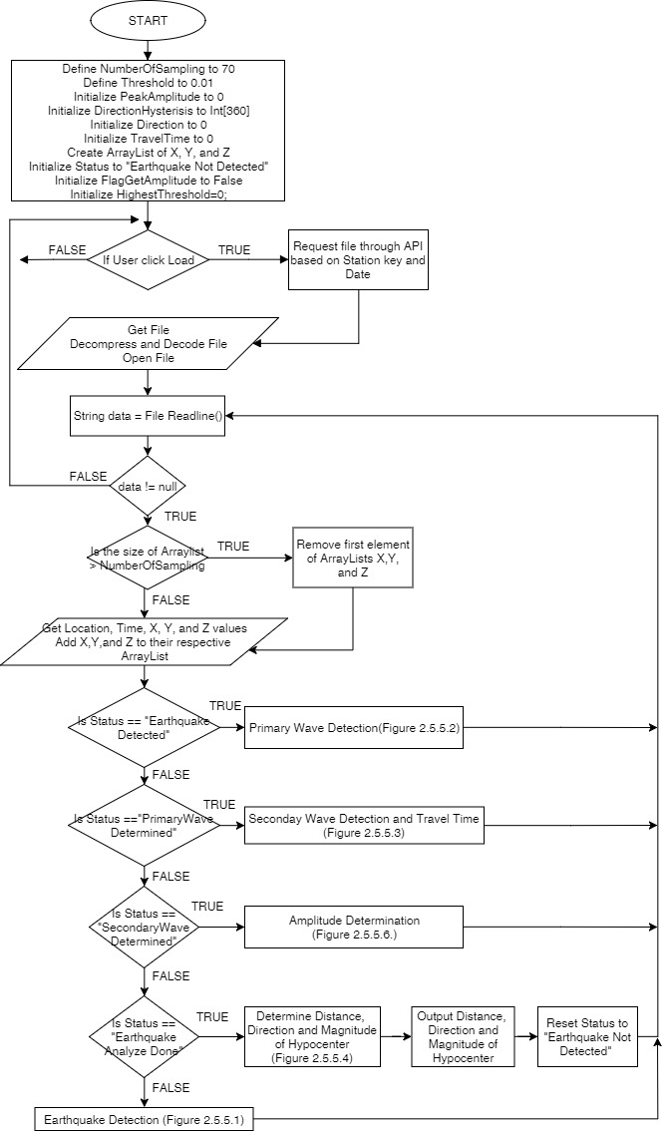
Figure 2.5.5 Earthquake Analyzing using C#
The figure above shows the general flowchart of the back end C# application. The status variable will define the status of the embedded Earthquake Detector.
      - Earthquake Detection
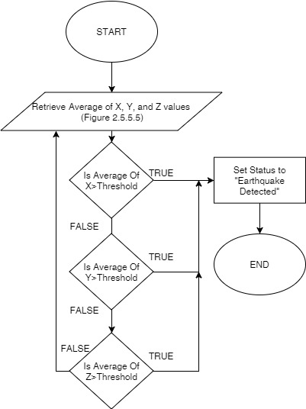
Figure 2.5.5.1 Earthquake Detection
The figure above defines how the software determines if it is an earthquake or not. It uses averaging of samples of X, Y, and Z to get the average value of the data. Please see Figure 2.2.5.5 to get details about average values of the data.

      - Primary Wave Detection
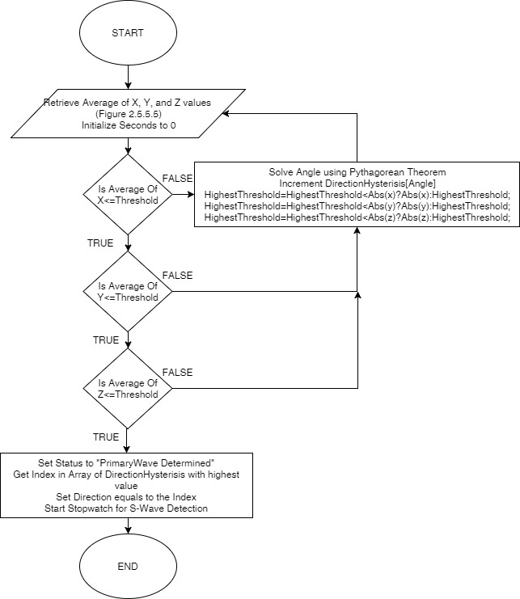
Figure 2.5.5.2 Primary Wave Detection
The figure above defines how the system determine if a primary wave has ended or not. This function will only trigger if the software has detected an earthquake.
      - Secondary Wave Detection and Travel Time Determination
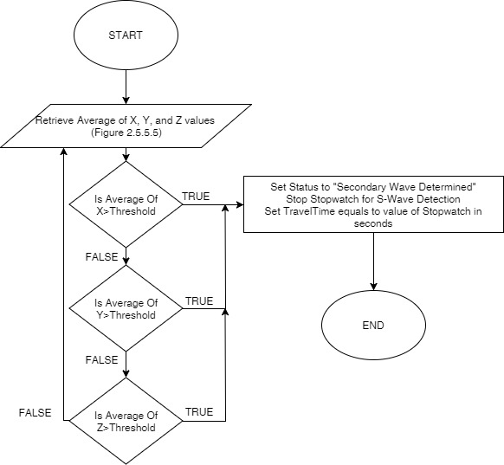
Figure 2.5.5.3 Secondary Wave Detection and Travel Time Determination
The figure above defines how the software determine if a secondary wave has occur. Secondary wave must be higher than primary wave. The function will only trigger if the software has determined a primary wave. Travel time defines the time travel starting from the arrival of primary wave until the arrival of secondary wave.

      - Determine Distance, Direction, and Magnitude of Hypocenter
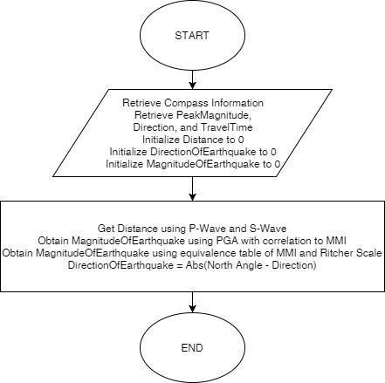
Figure 2.5.5.4 Determine Distance, Direction, and Magnitude of Hypocenter
The figure above defines how the software solve for distance, direction, and magnitude of hypocenter. In this case, distance traveled by the wave is define as the Travel Time multiply by 8 which is a standard speed of travelling waves. Magnitude and Direction of the hypocenter is defined above.
      - Retrieve Average Values of X, Y, and Z
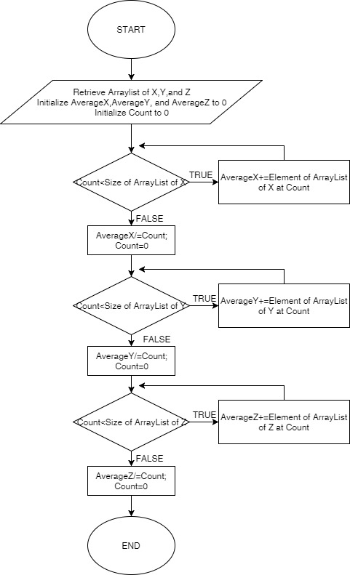
Figure 2.5.5.5 Retrieve Average Value of X, Y, and Z
The figure above works like a circular queue. It uses averaging of samples by gathering the samples and put it into the circular queue.
      - Peak Amplitude Determination
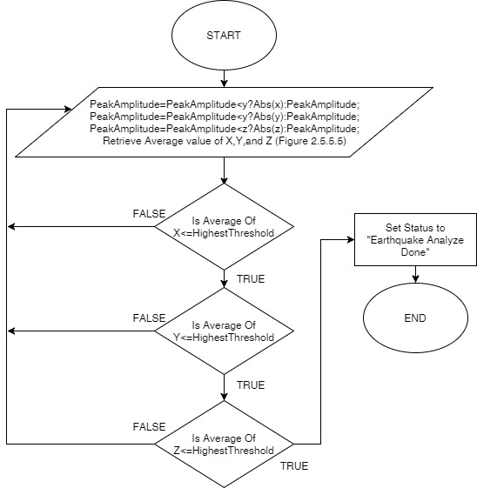
Figure 2.5.5.6 Peak Amplitude Determination
The figure above defines how the system determine the peak amplitude of the earthquake. The software will pick the highest absolute value of g from the three axis.

  - TESTING AND DATA GATHERING

2.6.1. Determining the accuracy of the device

To test the accuracy of the device, the data generated by our device will be compare to the data generated by the PHIVOLCS’s digitizer.

2.6.2. Determining the output speed of the device

In determining the output speed of the device, the database will be needed. The number of samples generated by the sensor can be shown in the database. All the files added in the database has time information within. Using that information, the actual output rate of the device can be derived.

2.6.3. Determining the direction by hitting the table or using a vibrator

Using a vibrator or hitting the table will create an artificial wave that will be used for the Earthquake analyzer software for determining direction.

2.6.4. Determining the data back-up capability

To test the back-up capability of the system, the database will be temporarily down to create a connection issue for the Android software. In this scenario, the Android software will be force to back-up the data into the external/internal storage.

2.6.5. Determining the connectivity and value display of Android

To test the connectivity and x, y, and z display of the Android display, the system will be run to check if the x, y, and z value is displayed correctly. If the three values are displayed correctly, therefore, the software has a good connection to the system’s digitizer.

2.6.5. Determining the gain feature workability

To test if the gain feature of the system is running or not, a voltmeter will be used to check the output of the amplifier of the circuit. If the user increases or decreases the gain, the voltmeter will output the response of the amplifier. In this scenario, we can test the workability of the gain feature.

